** Question/Answer Booklet**

**Name:**

**PHYSICAL EDUCATION STUDIES YEAR 11 ATAR**

**Biomechanics Test 17 May 2018**

**Time allowed for this paper**

Working time for paper: 40 min

**Structure of this paper**

|  |  |  |  |
| --- | --- | --- | --- |
| Section | Number of questions available | Number of questions to be attempted | Marks available |
| **Section One:**  Multiple-Choice | 5 | 5 | 5 |
| **Section Two:**  Short Answer | 5 | 5 | 20 |
| **Section Three:**  Extended Answer | 1 | 1 | 10 |
|  |  | **TOTAL:** | **35** |

**Multiple Choice (5 marks)**

1. Velocity is calculated by

(a) dividing distance travelled by time taken.

(b) dividing displacement by time taken.

(c) multiplying distance travelled by time taken.

(d) multiplying displacement by time taken.

2. A defender increases their velocity as they run towards an opposition player. The ball changes possession and the defender becomes an attacker. They slow down to change direction towards their goal and then increase their velocity again to make ground towards the scoring end. The acceleration of the player as they perform these movements is best described as

(a) positive acceleration then negative acceleration then positive acceleration.

(b) positive acceleration then negative acceleration.

(c) negative acceleration then positive acceleration.

(d) positive acceleration then zero acceleration then positive acceleration.

3. A baseball player fields the ball near second base and must get the ball to first base as quickly as possible to get the batter out. The player should throw with a

(a) high trajectory and high velocity.

(b) flat trajectory and high velocity.

(c) release angle of 45 degrees.

(d) high trajectory and low velocity.

4. When performing activities where a high velocity of release is optimal, the sequential movement of segments, allows the velocity of the previous segment to be added to the next, transferring the highest possible velocity to the projectile. Which graph best displays the ideal timing of movements to create the highest possible velocity?

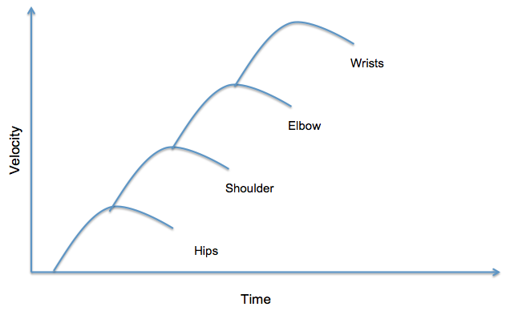

(a)

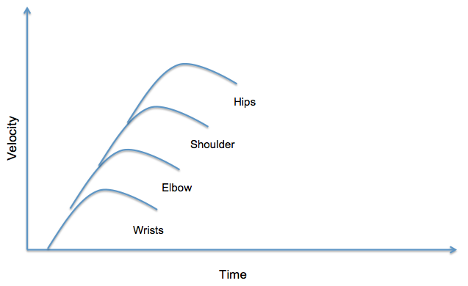(b)

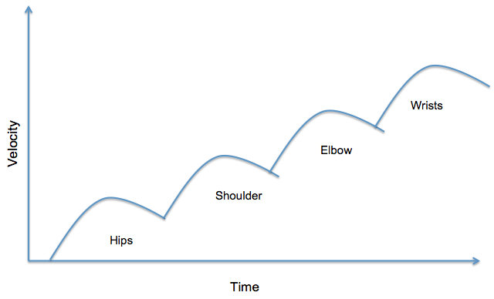(c)

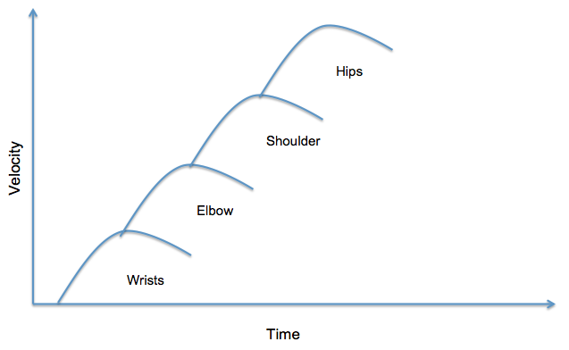

(d)

5. When an object is thrown from a height that is greater than the landing height, the optimal angle of release to reach maximum distance is

(a) 45 degrees.

(b) greater than 45 degrees.

(c) less than 45 degrees.

(d) 90 degrees.

**Short Answer (20 marks)**

**Question 6 (3 marks)**

Cycling is a good example of general motion. Explain this statement.

**Question 7 (7 marks)**

A set of golf clubs contains woods and irons. The image below shows a set of irons. The iron closest to the ball is called a ‘9 iron’ and the iron on the far left is called a ‘1 iron’.

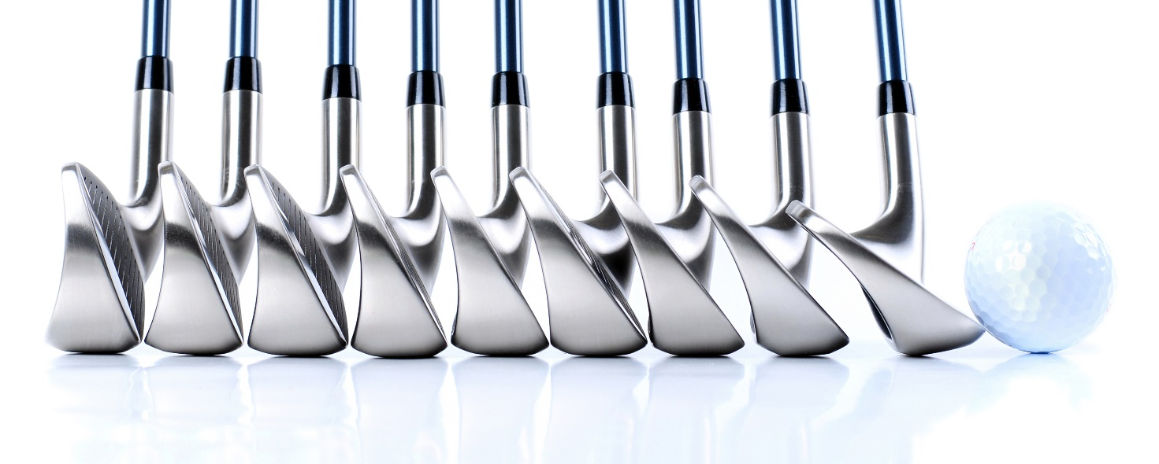

(a) Explain why a golfer would have a range of irons, from a 1 iron to a 9 iron, in their golf bag. (4 marks)

(b) Woods are designed with longer shafts than irons. Use your knowledge of angular velocity to explain the benefit of using a wood as opposed to an iron. (3 marks)

**Question 8 (3 marks)**

The images below show a sprinter preparing for the start of a race. With reference to centre of gravity and base of support, discuss how a sprinter changes their body position (from image 1 to image 2) to manipulate their stability and ensure that they have the most successful race start.

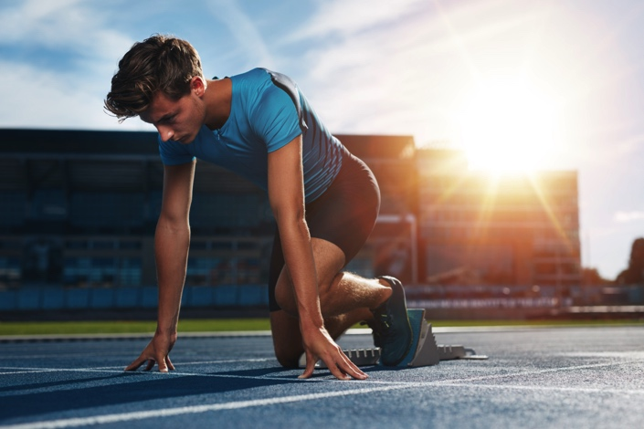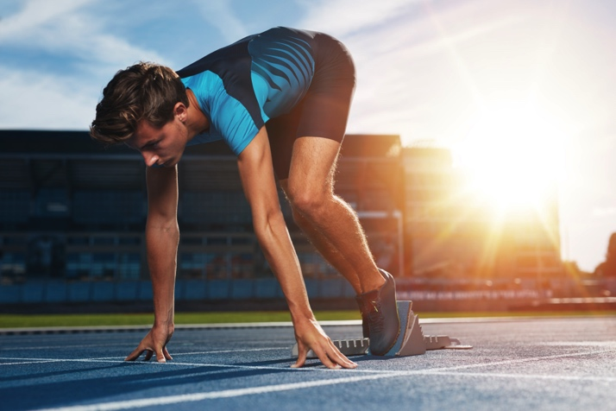

Image 1 Image 2

**Question 9 (4 marks)**

Weighted vests can be worn by athletes to increase their workload during a training session. Wearing a weighted vest makes exercises where the athlete is required to overcome gravity more demanding and therefore can increase training benefits. With reference to Newton’s Third Law of Motion, explain why an athlete may also increase their risk of injury by wearing a weight vest for activities such as running.

**Question 10 (3 marks)**

In basketball, most competitive teams will allocate players to set roles. Commonly used terms for describing the roles of players on a basketball team are guards, forwards and centres. Generally, guards tend to be the shortest players on the team and are relied on for their speed and agility. The centres are usually taller and play close to the ring, gathering rebounds and contesting shots. Explain why guards are often shorter than centres.

**Extended Answer (10 marks)**

**Question 11 (10 marks)**

The application of sequential and simultaneous movement depends on the nature of the action being performed. Describe sequential movement and simultaneous movement. Providea specific example where each movement would be preferred. Justify your response.

Biomechanics test 2018 MEMO:

**Multiple Choice (5 marks)**

1. Velocity is calculated by

(a) dividing distance travelled by time taken.

(b) dividing displacement by time taken.

(c) multiplying distance travelled by time taken.

(d) multiplying displacement by time taken.

2. A defender increases their velocity as they run towards an opposition player. The ball changes possession and the defender becomes an attacker. They slow down to change direction towards their goal and then increase their velocity again to make ground towards the scoring end. The acceleration of the player as they perform these movements is best described as

(a) Positive acceleration then negative acceleration then positive acceleration.

(b) positive acceleration then negative acceleration.

(c) negative acceleration then positive acceleration..

(d) positive acceleration then zero acceleration then positive acceleration.

3. A baseball player fields the ball near second base and must get the ball to first base as quickly as possible to get the batter out. The player should throw with a

(a) high trajectory and high velocity.

(b) flat trajectory and high velocity.

(c) release angle of 45 degrees.

(d) high trajectory and low velocity.

4. When performing activities where a high velocity of release is optimal, the sequential movement of segments, allows the velocity of the previous segment to be added to the next, transferring the highest possible velocity to the projectile. Which graph best displays the ideal timing of movements to create the highest possible velocity?

(a)

(b)



(c)

(d)

5. When an object is thrown from a height that is greater than the landing height, the optimal angle of release to reach maximum distance is

(a) 45 degrees.

(b) greater than 45 degrees.

(c) less than 45 degrees.

(d) 90 degrees.

**Short Answer (20 marks)**

**Question 6 (3 marks)**

Cycling is a good example of general motion. Explain this statement.

|  |  |
| --- | --- |
| Description | Marks |
| General motion is the combination of angular and linear motion/General motion is linear motion caused by angular motion | 1 mark |
| Cycling involves angular motion of the joints at the hip, knee and ankle/Cycling involves angular motion as the wheels rotate on an axis | 1 mark |
| This causes the bicycle (or rider) to undergo linear motion | 1 mark |

**Question 7 (7 marks)**

A set of golf clubs contains woods and irons. The image below shows a set of irons. The iron closest to the ball is called a ‘9 iron’ and the iron on the far left is called a ‘1 iron’.

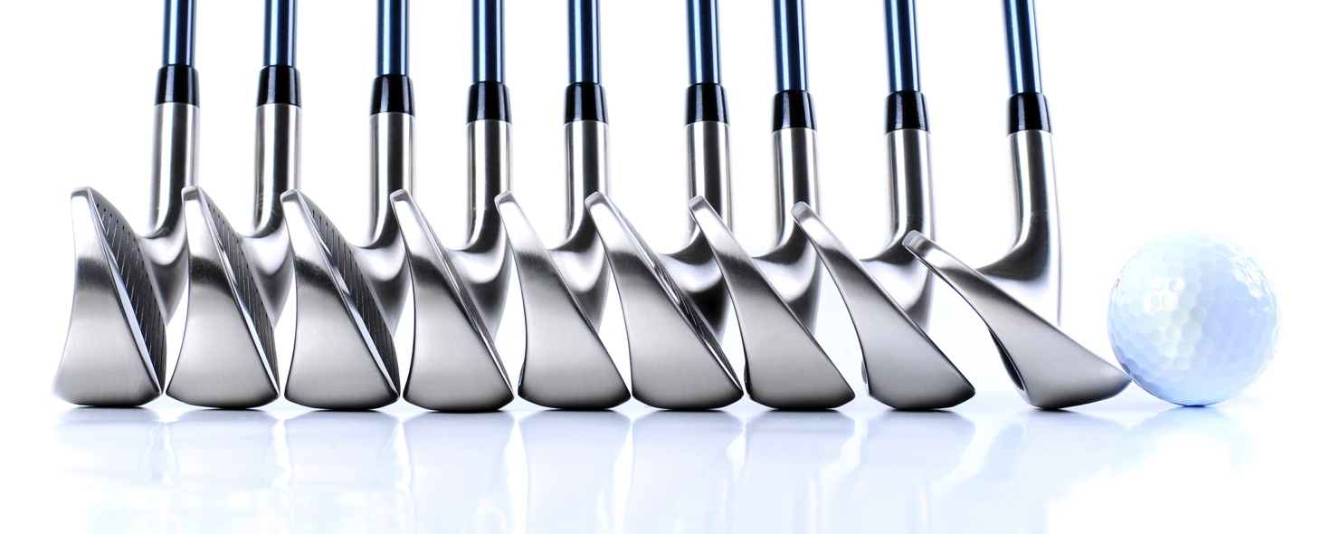

(a) Explain why a golfer would have a range of irons, from a 1 iron to a 9 iron, in their golf bag. (4 marks)

|  |  |
| --- | --- |
| Description | Marks |
| The faces of the different irons create a different angle of release as they strike the ball. | 1 mark |
| 1 irons create a lower angle of release compared to a 9 iron which has the highest angle of release (or similar) | 1 mark |
| Any two:   * 9 iron (or higher angle of release) will be used when hitting from a lower height of release than the intended landing height (or hitting out of a hole or bunker) * 9 iron (or irons with a higher number) are better when hitting over a shorter distance. * 1 iron (or lower angle of release) will be used when hitting from a higher height of release than the intended landing height (or hitting from a hill) * a greater angle of release (iron’s higher in number) will give a greater vertical distance and a lower horizontal distance * a lower angle of release (irons lower in number) will give a greater horizontal distance and a lower vertical distance | 1 mark each (max 2 marks) |

(b) Woods are designed with longer shafts than irons. Use your knowledge of angular velocity to explain the benefit of using a wood as opposed to an iron. (3 marks)

|  |  |
| --- | --- |
| Description | Marks |
| The longer the shaft, the greater the radius of rotation (increased radius of rotation) | 1 mark |
| The linear velocity of the club head is equal to the radius of rotation multiplied by the angular velocity | 1 mark |
| The greater the linear velocity of the club head on impact, the further the ball can be hit  OR  Using a wood allows the ball to travel further (or faster) | 1 mark |

**Question 8 (3 marks)**

The images below show a sprinter preparing for the start of a race. With reference to centre of gravity and base of support, discuss how sprinter changes their body position (from image 1 to image 2) to manipulate their stability and ensure that they have the most successful race start.

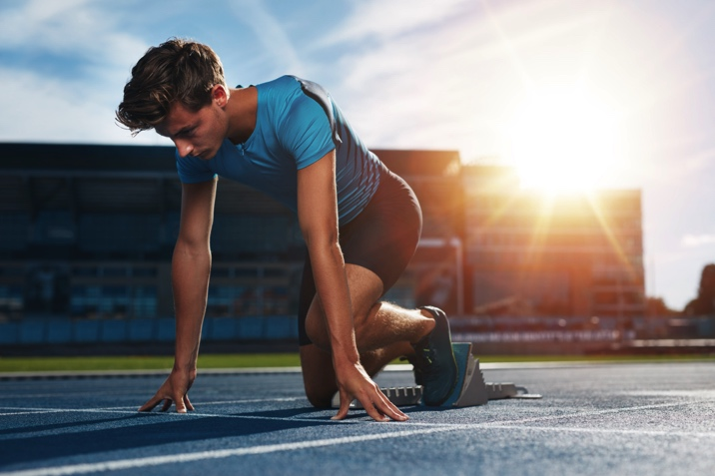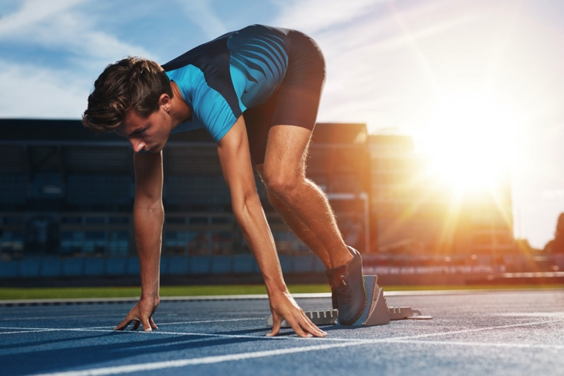

Image 1 Image 2

|  |  |
| --- | --- |
| Description | Marks |
| The runner leans forward (or straightens their legs) to shift their centre of gravity outside their base of support | 1 mark |
| By doing this the runner is decreasing their stability | 1 mark |
| Decreased stability allows the runner to have a faster reaction time | 1 mark each |

**Question 9 (4 marks)**

Weighted vests can be worn by athletes to increase their workload during a training session. Wearing a weighted vest makes exercises where the athlete is required to overcome gravity more demanding and therefore can increase training benefits. With reference to Newton’s Third Law of Motion, explain why an athlete may also increase their risk of injury by wearing a weight vest for activities such as running.

|  |  |
| --- | --- |
| Description | Marks |
| Defines Newtons Third Law;  To every action there is an equal and opposite reaction | 1 mark |
| Force is the product of mass and acceleration (Or Force=Mass x Acceleration) | 1 mark |
| The greater mass of the weight vest increases the downward force the runner exerts on the ground | 1 mark |
| Therefore the ground will exert an equally greater opposing force on the runner which increases risk of injury | 1 mark |

**Question 10 (3 marks)**

In basketball, most competitive teams will allocate players to set roles. Commonly used terms for describing the roles of players on a basketball team are guards, forwards and centres. Generally guards tend to be the shortest players on the team and are relied on for their speed and agility. The centres are usually taller and play close to the ring, gathering rebounds and contesting shots. Explain why guards are often shorter than centres.

|  |  |
| --- | --- |
| Description | Marks |
| Shorter players have a lower centre of gravity | 1 mark |
| Lower centre of gravity creates greater stability | 1 mark |
| Guards are able to perform quick movements (or change direction quickly) without loosing their balance | 1 mark each |

**Extended Answer (10 marks)**

**Question 11 (10 marks)**

The application of sequential and simultaneous movement depends on the nature of the action being performed. Describe sequential movement and simultaneous movement. Provide a specific example where each movement would be preferred.

|  |  |
| --- | --- |
| Description | Marks |
| Description of simultaneous movement:  All body segments move at the same time  Involved in explosive activities  And  Used in activities where accuracy is more important than speed or distance | 1 mark  1 mark  1 mark |
| Example of simultaneous movement (Any of the following)  Long jump  Weight lifting  High jump  Basketball free throw  (or other valid response) | 1 mark max |
| Justification (Must relate to example):  IE: Long jump involves explosive power on take off to achieve the greatest distance. | 1 mark |
| Description of sequential movement (Any three of the following):  Body parts move in a sequence (Or body parts move one after the other  Largest body parts move first, followed by the progressively smaller body parts  Momentum is transferred through body parts to achieve summation of momentum  Optimal momentum is achieved when a body begins movement when the previous body part has reached maximal velocity (Or optimal momentum is achieved through efficient timing of each segment)  Used when the aim of the activity is to maximise the velocity of a projectile or distal body part | 3 mark max  1 mark  1 mark  1 mark  1 mark  1 mark |
| Example of sequential movement (Any of the following):  Golf  Discus  Shot put  Javelin  Karate (or other martial arts)  (or other valid response) | 1 mark max |
| Jusification (Must relate to example):  IE: Discus requires maximal velocity to be transferred into the projectile to gain the greatest distance | 1 mark |